EMPLOYEE MANAGEMENT SYSTEM

Software Requirements Specification

-Denis Kotolenko-

**CONTENT**

1. INTRODUCTION 3

1.1. PURPOSE OF THIS DOCUMENT 3

1.2. DESCRIPTION OF PRODUCT 4

1.3. INTENDED AUDIENCE 4

1.4. SCOPE 4

1.5. DEFINTIONS 4

1.6. ADDITIONAL NOTES 4

2. SOFTWARE REQUIREMENT SPECIFICATIONS 4

2.1. Add Employee Tab 4

2.1.1. GUI 4

2.1.2. DESCRIPTION 5

2.1.3. SEQUENCE DIAGRAM – Add Employee 5

2.2. View Employee Tab 5

2.2.1. GUI 5

2.2.2. DESCRIPTION 6

2.2.3. Search Employees 6

2.2.3.1. SEQUENCE DIAGRAM – Search Employees 6

2.2.4. Delete Employees 7

2.2.4.1. GUI 7

2.2.4.2. DESCRIPTION 7

2.2.4.3. SEQUENCE DIAGRAM – Delete Employee 7

2.2.5. Edit Employee 8

2.2.5.1. GUI 8

2.2.5.2. DESCRIPTION 8

2.2.5.3. SEQUENCE DIAGRAM – Edit Employee 8

2.2.6. Back, Next Buttons and Current Page label 9

2.2.6.1. GUI 9

2.2.6.2. DESCRIPTION 9

2.2.6.3. SEQUENCE DIAGRAM – Back, Next button 10

2.2.7. Export Grid to CSV 10

2.2.7.1. GUI 10

2.2.7.2. DESCRIPTION 11

2.2.7.3. SEQUENCE DIAGRAM – Export Grid to CSV 11

2.3. Edit Employee Form 12

2.3.1. GUI 12

2.3.2. DESCRIPTION 12

2.3.3. SEQUENCE DIAGRAM – Edit Employee Save 13

3. EXTERNAL REQUIREMENTS 13

3.1. Additional packages 13

3.2. Operating system requirement 13

3.3. Hardware 13

3.4. Network 13

3.5. QUESTION TO INTERVIEWER 13

# INTRODUCTION

## PURPOSE OF THIS DOCUMENT

Purpose of this document is to show Employee software specifications and its behaviour.

## DESCRIPTION OF PRODUCT

Employee project is created by Denis Kotolenko as part of UPS recruitment process. It consists of multiple modules: Add Employee, Search Employees, Edit Employee, Delete Employee, Export to CSV file. All of the data used in this project is located on: https://gorest.co.in

## INTENDED AUDIENCE

This document is intended for use by UPS experts in recruitment process.

## SCOPE

Implement modules: Add Employee, Search Employee, Edit Employee, Delete Employee, Export To CSV.

## DEFINTIONS

WEB API – Refered to <https://gorest.co.in> web api used as main data source in this project.

APP – Refered to this app. Employees Win Forms app.

## ADDITIONAL NOTES

Application used for drawing sequence diagrams is: https://app.diagrams.net/  
Sequence diagrams in exported format can be found on „Sequence Diagrams“ folder in project.

# SOFTWARE REQUIREMENT SPECIFICATIONS

## Add Employee Tab

### GUI

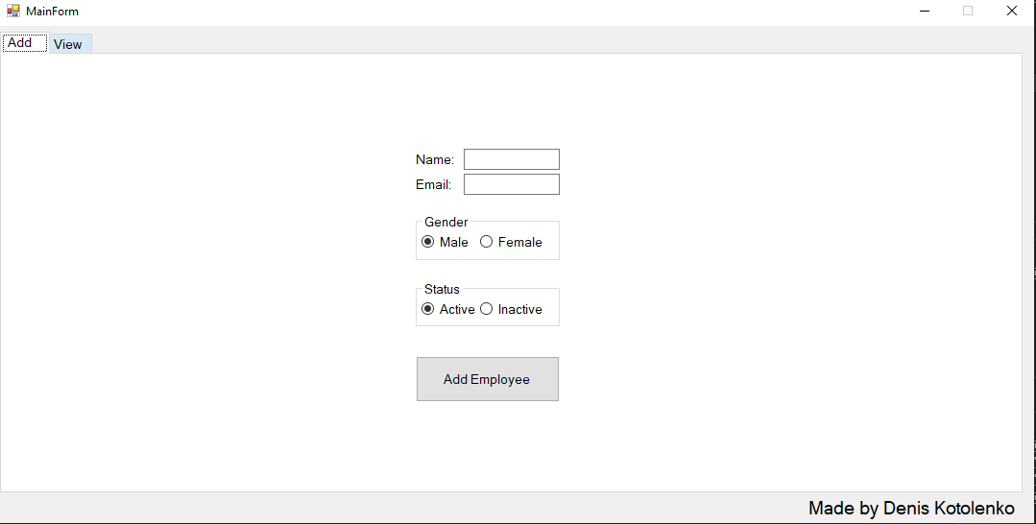

### DESCRIPTION

This is main page which opens up when program is started. In this page user can add employee. There is validation implemented on Textboxes „Name“ and „Email“. User can not enter empty name, and needs to enter mail in format [xxxx@xxxx.xx](mailto:xxxx@xxxx.xx).

There are only 2 possible genders because WEB API does not support other possible genders (Other, Trans, Not-want-to-tell etc). There are also 2 possible statuses (Active and Inactive). This is also dictated by WEB API behavior.

To Add Employee to WEB API user should enter valid Employee and click on button „Add Employee“.

### SEQUENCE DIAGRAM – Add Employee

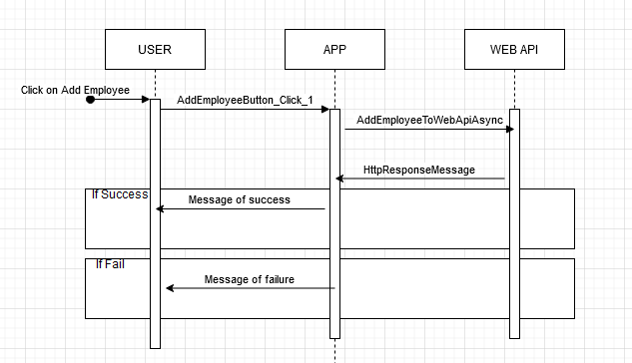

## View Employee Tab

### GUI

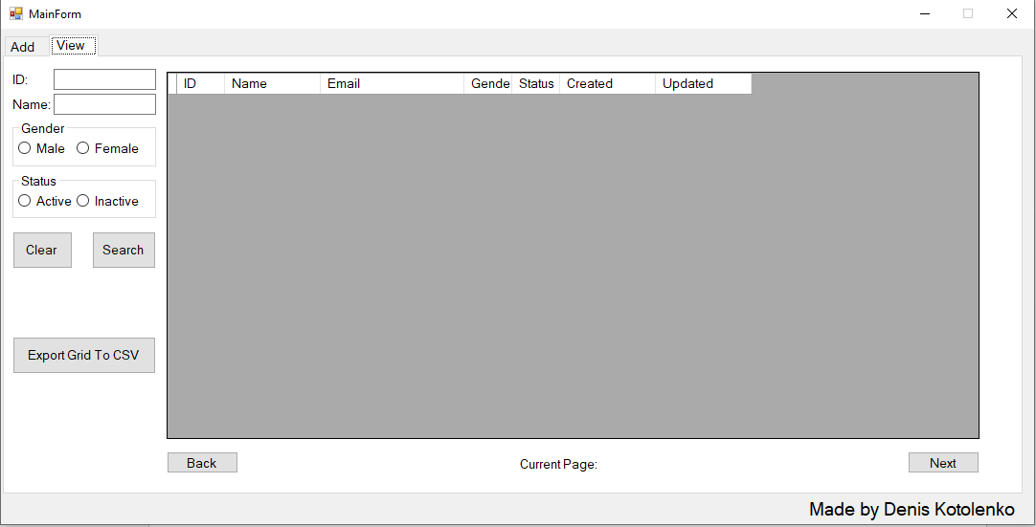

### DESCRIPTION

This tab is intended for multiple functionalities. Search Employees, Edit Employees, Delete Employees, Paging (back page, next page), Export Grid To CSV and Clear.

### Search Employees

In order to find employees from WEB API user should enter one or multiple criteria shown on 2.2.1 GUI.

**ID** – ID of employee we want to search.

**Name** – Name of employee we want to find. No need to input full name as „LIKE“ operator is implemented on WEB API and will show results even with partial input. Example entering „aab“ will retrieve all employees from WEB API which have in its name „aab“. Valid employees: aabraham, baabraham etc...

**Gender** – Will create search criteria for all employees with selected gender. Can be used in isolation to only find employees of certain gender. Supported values by WEB API are „Male“ and „Female“

**Status** – Will create search criteria for all employees with selected Activity. Can be used in isolation to only find employees of certain activity. Supported values by WEB API are „Active“ and „Inactive“.

#### SEQUENCE DIAGRAM – Search Employees

When user enters data in search boxes and clicks „Search“ button. Search sequence happens.

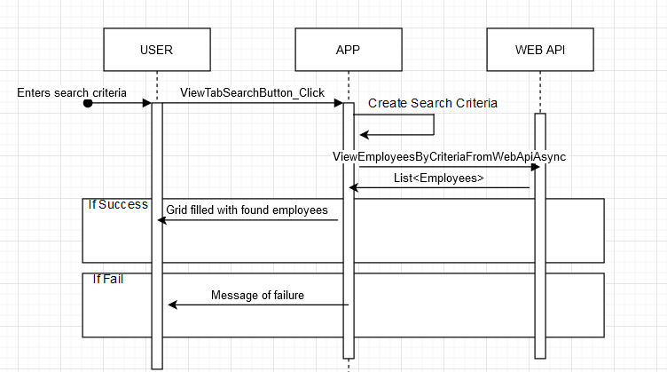

### Delete Employees

#### GUI

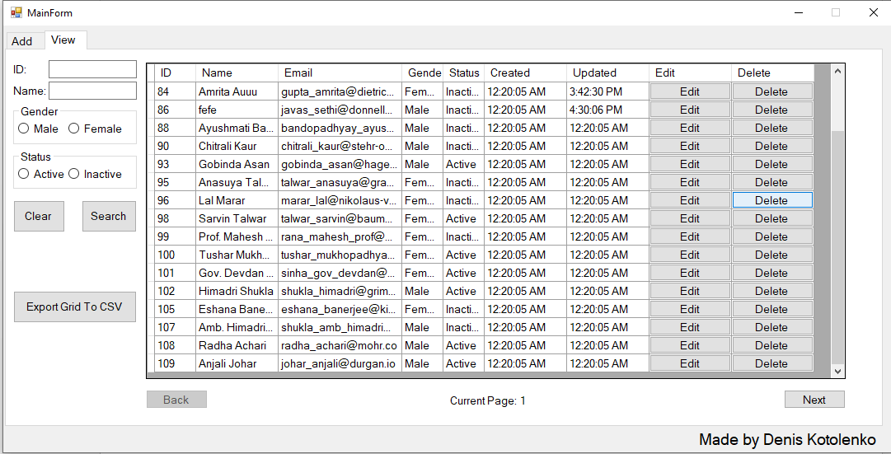

#### DESCRIPTION

User can delete employee by clicking „Delete“ button on any employee. After deleting employee grid will automaticaly refresh.

#### SEQUENCE DIAGRAM – Delete Employee

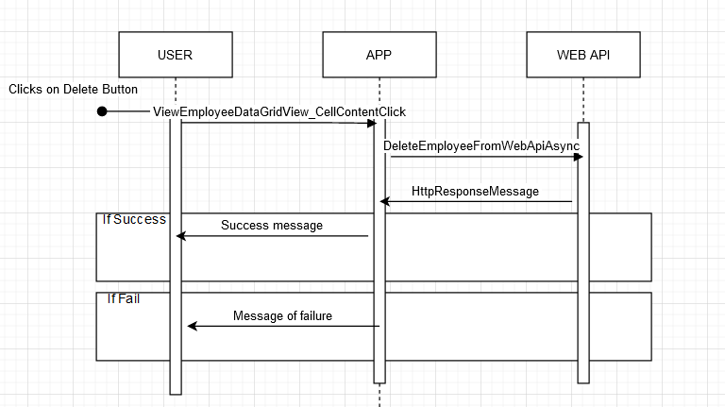

### Edit Employee

#### GUI

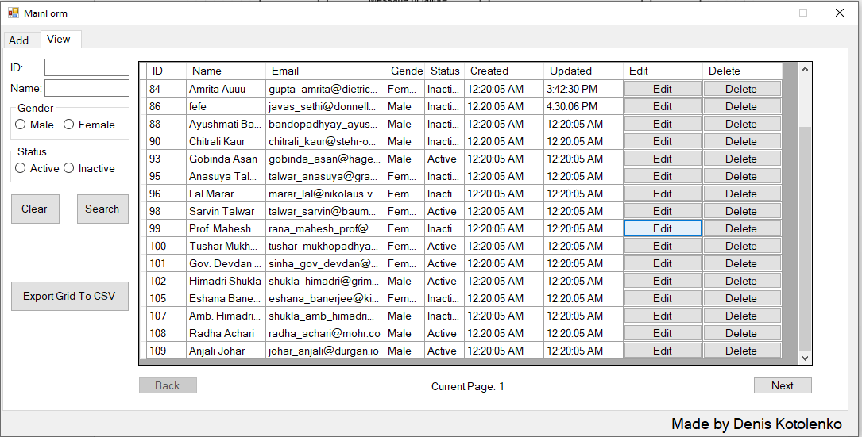

#### DESCRIPTION

User can edit any employee shown on grid. Click on „Edit“ button opens up new form which is responsible for editing employees. This form and its functionality can be found in this document.

#### SEQUENCE DIAGRAM – Edit Employee

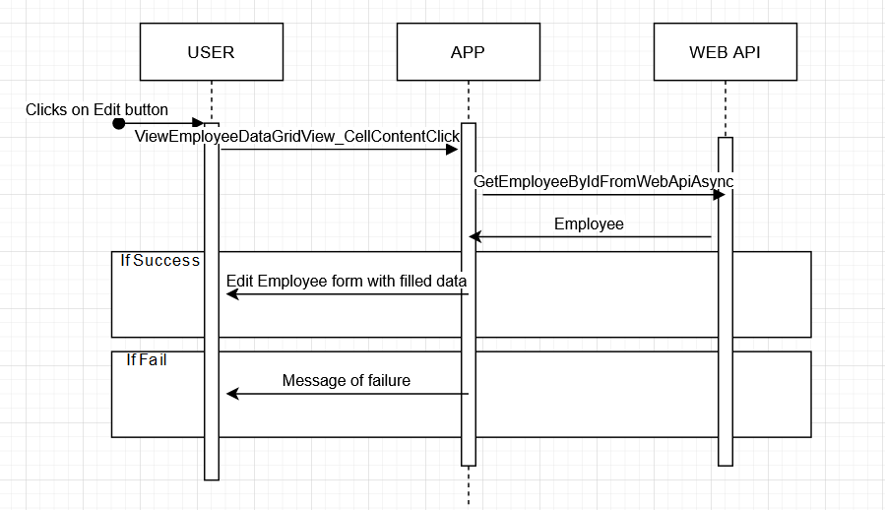

### Back, Next Buttons and Current Page label

#### GUI

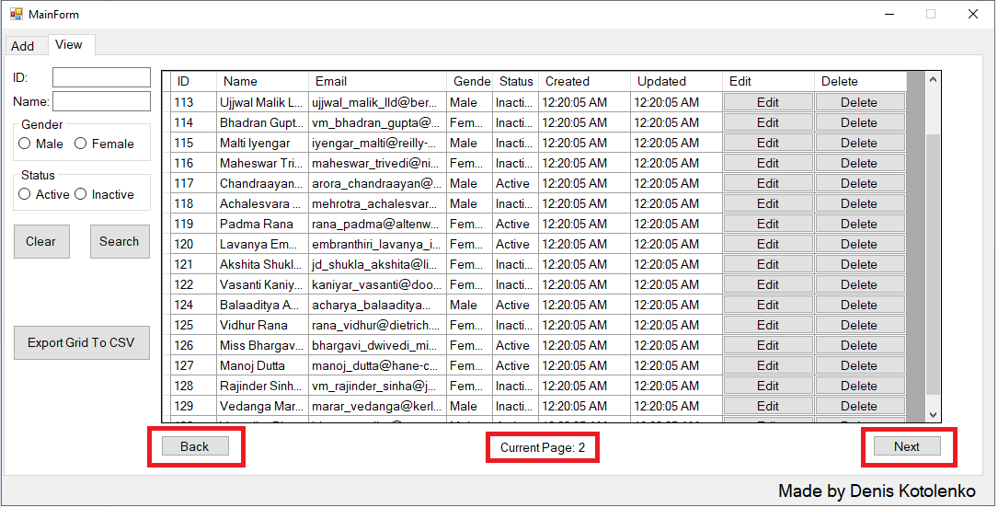

#### DESCRIPTION

1. Back button

This button is used for paging back. On clicking this button it will collect search criteria from texboxes and check boxes and current page number. This will trigger parametrized refresh on grid with parameters: „SearchCriteria“, „Current Page Number“. This button is disabled if grid is on page 1. System internaly knows how much pages there are – maximum page number.

1. Next button

This button is used for going to next page. On clicking this button it will collect search criteria from texboxes and check boxes and current page number. This will trigger parametrized refresh on grid with parameters: „SearchCriteria“, „Current Page Number“. This button is disabled if grid last page. System internaly knows how much pages there are – maximum page number.

1. Current page label

This label shows user what is current page of search results.

#### SEQUENCE DIAGRAM – Back, Next button

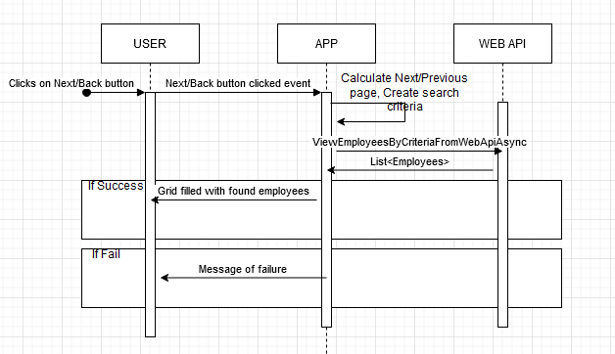

### Export Grid to CSV

#### GUI

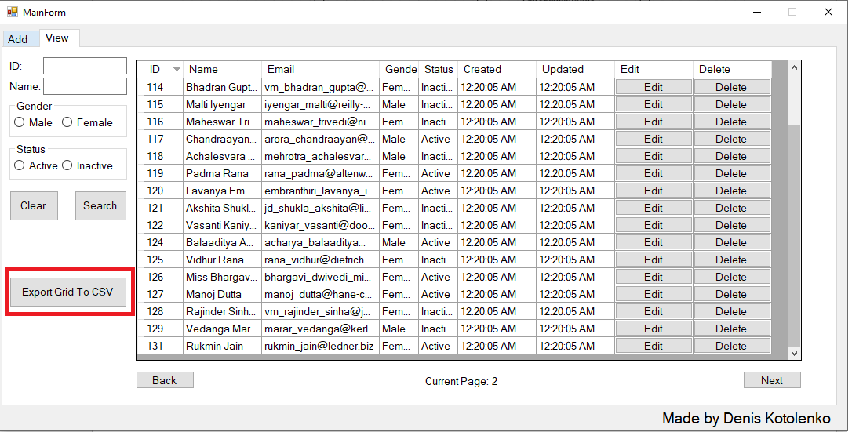

CSV FILE AFTER EXPORT:

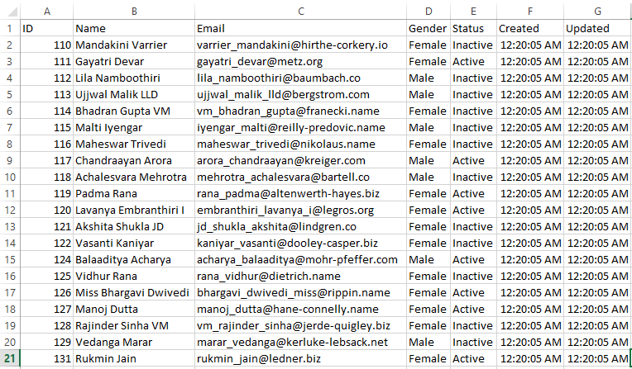

#### DESCRIPTION

In order to Export Grid to CSV file user first have to search for employees, and they need to be present in grid. If user clicks on „Export Grid To CSV“ button if grid is empty user will get „No Record to export“ message popup. All data that WEB API has about employees is shown. Currently number of employees per page is set by WEB API to be 20 employees.

#### SEQUENCE DIAGRAM – Export Grid to CSV

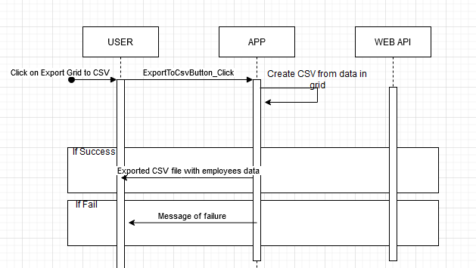

## Edit Employee Form

### GUI

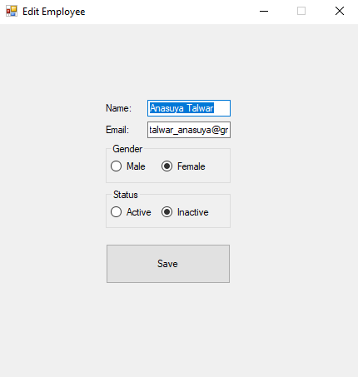

### DESCRIPTION

To reach this panel user must first find employee using „View“ tab page, and click on button Edit.

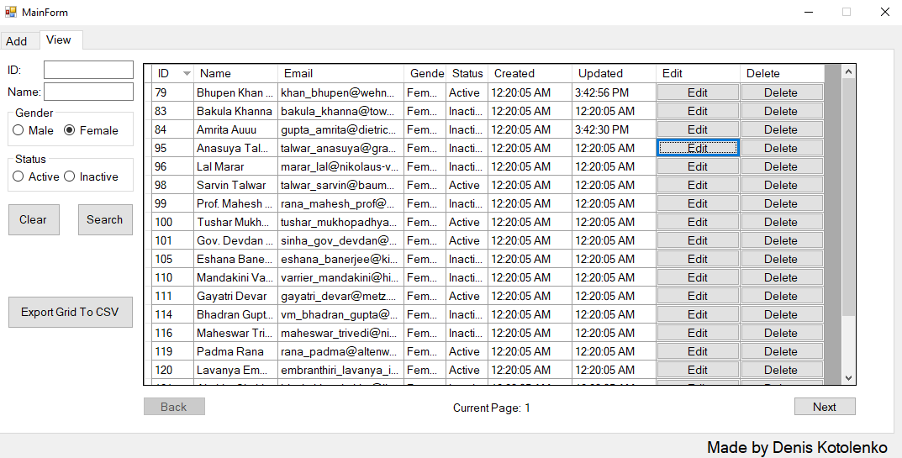

Click on this „Edit“ button in grid will open new form window with filled data about selected employee. In order to update selected employee user must click on button „Save. There is validation implemented on Textboxes „Name“ and „Email“. User can not enter empty name, and needs to enter mail in format [xxxx@xxxx.xx](mailto:xxxx@xxxx.xx). User cannot edit employee „Created“ date and „Updated“ date as that is internaly controlled and filled by WEB API.

### SEQUENCE DIAGRAM – Edit Employee Save

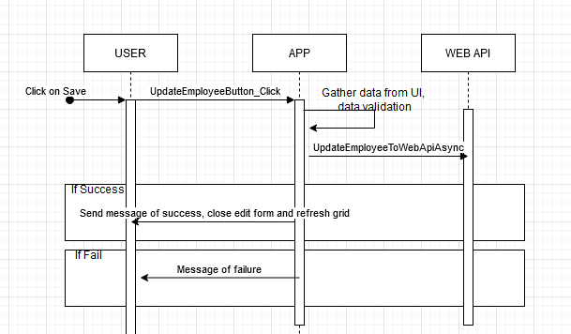

# EXTERNAL REQUIREMENTS

## Additional packages

This information can be found in document „AdditionalPackages.docx“ included in project.

## Operating system requirement

As this is developer under .NET framework 4.7.1 it requires windows os to run.

## Hardware

Anything better than potato will run this.

## Network

User must have network acess for application to work as main logic is working with data from WEB API.

## QUESTION TO INTERVIEWER

**QUESTION: What is potato?**

**ANSWER: Green Lantern**

**---I WILL ASK THIS QUESTION TO INTERVIEWER TO CHECK IF HE/SHE ATLEAST GLANCED OVER THIS DOCUMENTATION!!!---**